DESIGN DOCUMENT:

Software Engineering Tool Suite

Rowan University

Senior Project

Professor Baliga

Prepared by Timothy McClintock

Contributions by Roger Morris, Cole Christensen, Krunal Patel, Dharmyk Pandya & Yousuf Ahmed

October 15th, 2017

Name **Main** 4

Description 4

Picture 4

Navigation 4

End-Points 4

Name **University Selection** 5

Description 5

Picture 5

Navigation 5

End-Points 5

Name **Password Reset** 7

Description 7

Picture 7

Navigation 7

End-Points 7

Name **Faculty Sign Up** 8

Description 8

Picture 8

Navigation 9

End-Points 9

Name **Student Sign Up** 10

Description 10

Picture 10

Navigation 11

End-Points 11

Name **Login** 12

Description 12

Picture 12

Navigation 12

End-Points 12

Name: **Profile** 13

Description 13

Picture 13

Navigation 13

End-Points 13

Name **Tool Kit** 14

Description 14

Picture 14

Navigation 14

End-Points 14

Name **Delete Tools** 15

Description 15

Picture 15

Navigation 15

End-Points 15

Name **Search** 16

Description 16

Picture 16

Navigation 16

End-Points 16

Name **Add Tools** 17

Description 17

Picture 17

Navigation 17

End-Points 17

Structure 18

Stack 18

Operating Environment 18

Server 18

Database 18

Code 18

Scheme 18

Development Tools 18

Repository 18

Web Page Resources 18

Cloud Server 19

Amazon Web Services 19

Service 19

Geographic Region 19

Security Group 19

Website Domain Name System: 19

Site Map 20

Definitions 21

User 21

Faculty 21

Student 21

Toolkit 21

University 21

Entity Relationship Diagram 1. 22

Entity Relationship Diagram 2. 23

Tables 24

Layout ‘accounts.sql’ 24

Layout ‘universities.sql’ 24

Table Diagram 25

## Name **Main**

### Description

This page is the first page a user will see after accessing our website through the URL. It will contain a navigation bar. The page will contain four primary features: Login, Sign-Up, About, and Contact.

### Picture



### Navigation

To: Sign Up Page, Login Page, About Us Page, Contact Us Page.

From: Main page.

### End-Points

*No change in endpoints.*

## Name **University Selection**

### Description

This page is the first page a user will see after selecting the Sign-Up button on the Main Page. The primary feature of this page is the capability for a user to validate their New Jersey State University in the websites database.

### Picture



### Navigation

To: Sign Up Page, Login Page, Main, Password Reset.

From: Main page.

### End-Points

*No change in endpoints.*

## Name **Password Reset**

### Description

This page is available to users from the Login in page and provides users a way to reset their passwords. The user will be prompted to fill in the following fields:

### Picture



### Navigation

To: Password Reset, Login

From: Login.

### End-Points

*The Data Table titled, ‘users’ in the database ‘accounts’ updates the columns ‘username’, ‘dob’ and ‘name’.*

## Name **Faculty Sign Up**

### Description

This page will have appropriate questions for faculty member to sign them up as a faculty.

Fields include:

Name, Gender, Birthdate, Email, Username, Password, and Faculty Selection.

### Picture



### Navigation

To: Profile Page

From: University Selection

### End-Points

The Data Table, ‘users’ exists in the ‘accounts’ database which contains Faculty Member information, and will get updated every time a Faculty Member registers with the website by Signing Up. The column that is updated to delineate faculty from student is titled ‘faculty’ and is of the value varchar(10). When the ‘faculty’ value is set to, ‘YES’, in the ‘accounts’ database a faculty profile experience is created.

## Name **Student Sign Up**

### Description

This page will have appropriate questions for a student to sign them up as a student.

Fields include:

Name, Gender, Birthdate, Email, Username, Password, and Faculty Selection.

### Picture



### Navigation

To: Profile Page

From: University Selection

### End-Points

The Data Table, ‘users’ exists in the ‘accounts’ database which contains Student information, and will get updated every time a Student registers with the website by Signing Up. The column that is updated to delineate students from a faculty member is titled ‘faculty’ and is of the value varchar(10). When the ‘faculty’ value is set to, ‘NO’, in the ‘accounts’ database a student profile experience is created.

## Name **Login**

### Description

This page will ask the user (Student or Faculty) to enter their login credentials.

This page includes two (2) fields: Username and Password.

### Picture



### Navigation

To: Student Welcome OR Faculty Welcome

From: Main

### End-Points

The Data Table ‘users’ in the database ‘accounts’ for the User Credentials (username and password) will be used to verify the user’s credentials by evaluation and comparison.

## Name: **Profile**

### Description

### 

This page will display basic profile information and allow a registered User to customize their profile with basic personal information. The options for profile customization include: Change Password, Change Username, Change Name, Change Email, Change Gender, and Change Date.

### 

### Picture



### Navigation

To: Change <field_name>, IDE Tool Page, Guide Line of Success, List of Clubs

From: Sign Up, Login, Tool Page

### End-Points

*The Data Table ‘users’ in the database ‘accounts’, will update a User’s personal information and display basic user profile information as appropriate.*

## Name **Tool Kit**

### Description

This Tool Kit will be dynamically adjustable and may contain 1..N tools as selected by each user.

### Picture



### Navigation

To: Profile Page, Login, Delete Tools, Search

From: Profile

### End-Points

*The Data Table ‘tools’ in the database ‘accounts’ will add a Students Tool based on its unique university id.*

## Name **Delete Tools**

### Description

This page is designed to delete a tool from a Users’ toolkit.

### Picture



### Navigation

To: Profile, Login, Main, Tool Kit

From: Tool Kit

### End-Points

*The Data Table ‘tools’ in the database ‘accounts’ will delete a Tool based on its unique university id.*

## Name **Search**

### Description

This page is designed to search tools from other Universities to add common tools to the User Toolkit.

### Picture



### Navigation

To: Profile Page, Login, Delete Page, Search

From: Student Welcome

### End-Points

*No change in endpoints.*

## Name **Add Tools**

### Description

This page is designed to add tools from other Universities to the User Toolkit.

### Picture



### Navigation

To: Main, Profile, Search,

From: Search

### End-Points

*The Data Table ‘tools’ in the database ‘accounts’ will update the tools selected based on its unique university id.*

# Structure

### Stack

#### Operating Environment

***Microsoft x86_64***

#### Server

***Apache/AWS***

#### Database

***MySQL***

#### Code

***PHP***

#### Scheme



Figure 1. Full Stack Architecture Scheme

### Development Tools

#### Repository

***GitHub***

#### Web Page Resources

***Bootstrap***

# Cloud Server

### Amazon Web Services

#### Service

***EC2 (Elastic Cloud Computing)***

#### Geographic Region

***Virginia, United States of America (US-EAST)***

#### Security Group

***Virtual Private Cloud Security Group:*** SWET_SG_useast1

#### Website Domain Name System:

***ec2-54-243-9-126.compute-1.amazonaws.com***

# Site Map



Figure 2. Site Map

# Definitions

## User

A user is defined as any entity that can create an account. A user is exclusively required to have an ‘.edu’ email account to register. As it pertains to this database a user will be defined as either a Student or Faculty. A University entity is associated to a Faculty member of the University once the Faculty member registers. A Student can only create an account if their University is registered in the database. The Faculty and Student Entities will all be linked to a Toolkit Entity.

### Faculty

A Faculty Entity has the following unique attributes: ID/Primary Key, Username and Email. A Faculty user also has DOB (date of birth), University Name, Name, Password, Role, and Gender. Each attribute has the following datatypes: ID/Primary Key: INT, Username: VARCHAR (100), Email: VARCHAR (100), DOB: DATE, University Name: VARCHAR (100), Name: VARCHAR (100), Password: VARCHAR (100), Role: VARCHAR (15), and Gender: VARCHAR (15). A Faculty and University account will be created simultaneously if the University is not in the database. The Faculty Toolkit is created with the account. The Toolkit will initially be empty/NULL. The Faculty is responsible for populating the Toolkit.

### Student

A Student entity has the following unique attributes: ID/Primary Key, Username and Email. A Student user also has DOB (date of birth), University Name, Name, Password, Role, and Gender. Each attribute has the following datatypes: ID/Primary Key: INT, Username: VARCHAR (100), Email: VARCHAR (100), DOB: DATE, University Name: VARCHAR (100), Name: VARCHAR (100), Password: VARCHAR (100), Role: VARCHAR (15), and Gender: VARCHAR (15). A Student account can only be created if the Student’s university is in the database. A Toolkit is created along with the Student account. The Toolkit will initially be empty/NULL. The Student is responsible for populating the Toolkit.

### Toolkit

The Toolkit entity is utilized by all other entities. The Toolkit has the following attributes: ID/Primary Key (ID/Primary Key from other entities), Name, URL, and Category. Each attribute has the following datatypes: ID/Primary: INT, Name: VARCHAR (100), URL: VARCHAR (100) and Category: VARCHAR (100). The ID/Primary Key of each of the other entities is used to store each entity’s tools.

### University

A University entity has the following unique attributes: ID/Primary Key and University Name. Each attribute has the following datatypes: ID/Primary Key: INT and University Name: VARCHAR (100). A University and its Toolkit are also created by the Faculty. The Faculty is responsible for populating the university’s Toolkit.

## Entity Relationship Diagram 1.

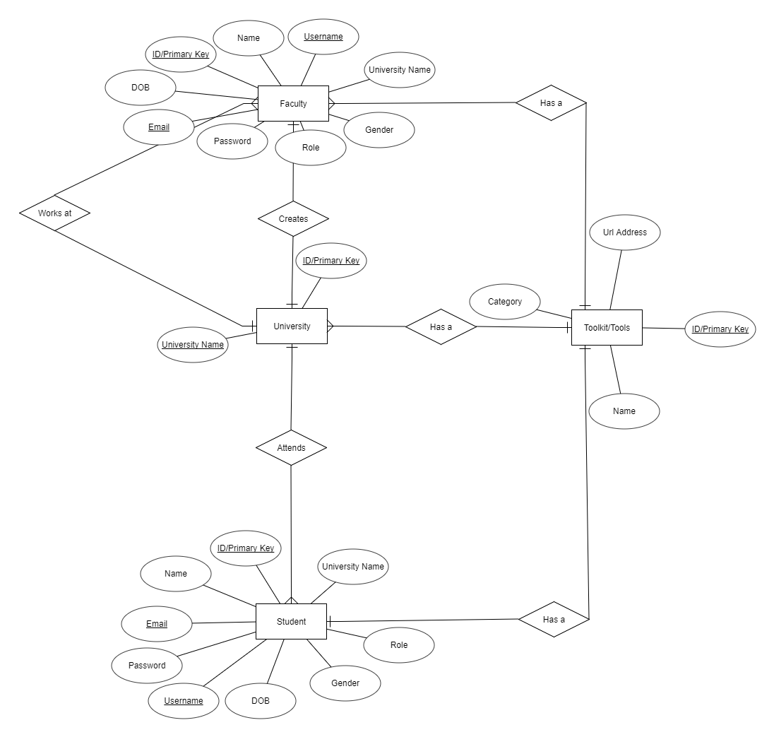

Figure 3. Entity Relationship Diagram

## Entity Relationship Diagram 2.

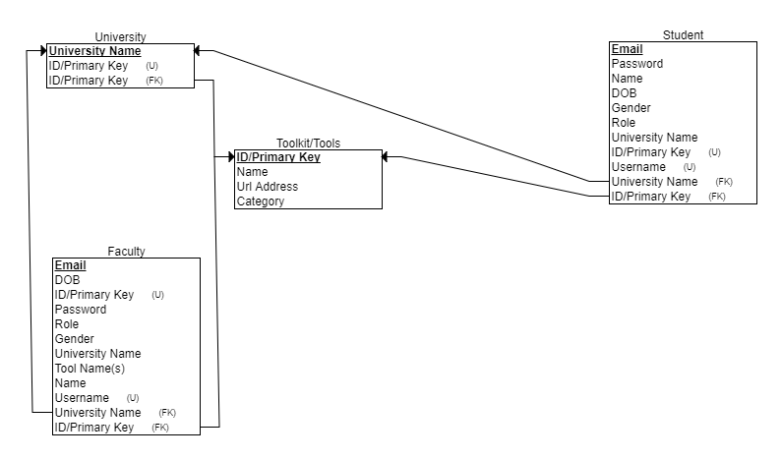

Figure 4. Entity Relationship Diagram

# Tables

## Layout ‘accounts.sql’

|  |  |  |
| --- | --- | --- |
| Name | Columns | Purpose |
| tools | 5 | Maintains basic login data. |
| users | 5 | Maintains Tool Kit data. |
| universities | 9 | Store/Merge User Data |

## Layout ‘universities.sql’

|  |  |  |
| --- | --- | --- |
| Name | Columns | Purpose |
| name | 5 | Maintains a University name attr. |
| univid | 5 | Maintains a UUID. |

Table Diagram

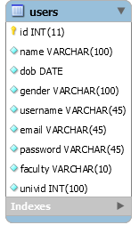 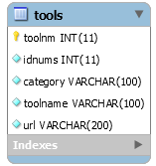 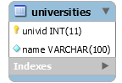

Figure 5. EER Table Diagrams produced in MySQL Workbench from accounts.sql and universities.sql schema.